Workplace Risk Assessments
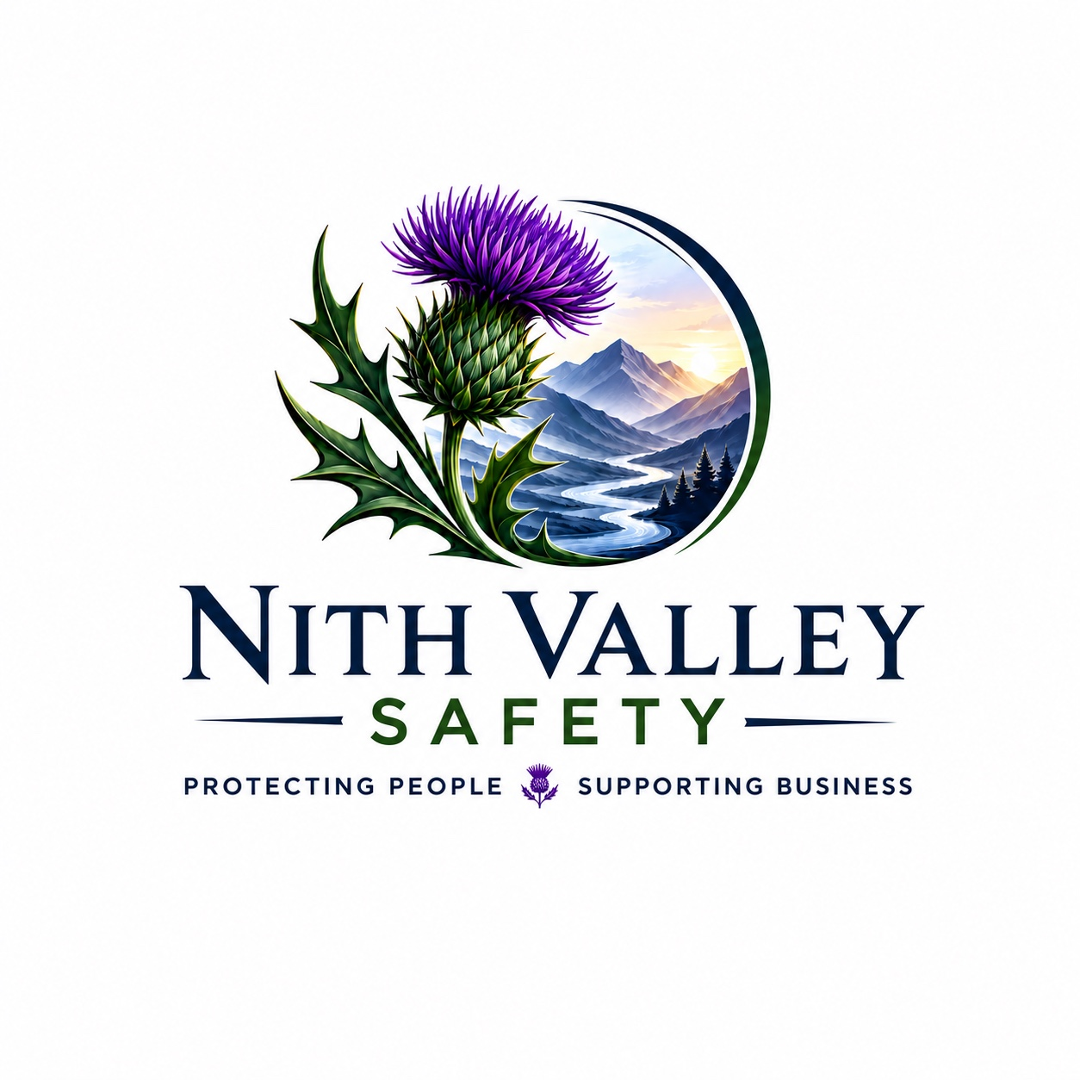
What is a Risk Assessment?
A risk assessment is a systematic process used to identify workplace hazards, evaluate the risks they present, and decide on suitable control measures to reduce the likelihood of injury, illness, or damage.

Why Risk Assessments Matter
- Help prevent accidents and ill health.
- Support compliance with UK health and safety law.
- Protect employees, contractors and visitors.
- Reduce business disruption and costs.
- Promote a positive safety culture.

The 5 Steps to Risk Assessment
- Identify the hazards.
- Decide who might be harmed and how.
- Evaluate the risks and implement controls.
- Record findings and implement actions.
- Review and update regularly.

Common Workplace Hazards
- Slips, trips and falls
- Manual handling
- Working at height
- Machinery and equipment
- Electricity
- Fire
- Hazardous substances (COSHH)
- Noise and vibration
- Display screen equipment
- Work-related stress

Hierarchy of Control
- Eliminate the hazard.
- Substitute with a safer option.
- Use engineering controls.
- Introduce administrative controls (training, procedures, supervision).
- Provide appropriate PPE as the last line of defence.

Reviewing Risk Assessments
- After an accident or near miss.
- When work processes change.
- When new equipment or substances are introduced.
- Following changes in legislation or guidance.
- At regular planned intervals.

Good Practice
- Involve employees in the assessment.
- Keep assessments simple and practical.
- Ensure actions are completed.
- Communicate findings to staff.
- Maintain records and review effectiveness.

Conclusion
Effective risk assessments are essential for creating a safe, healthy and legally compliant workplace. Identifying hazards, controlling risks and reviewing assessments regularly helps protect people while supporting business performance.

