Health and Safety Documentation in the Workplace
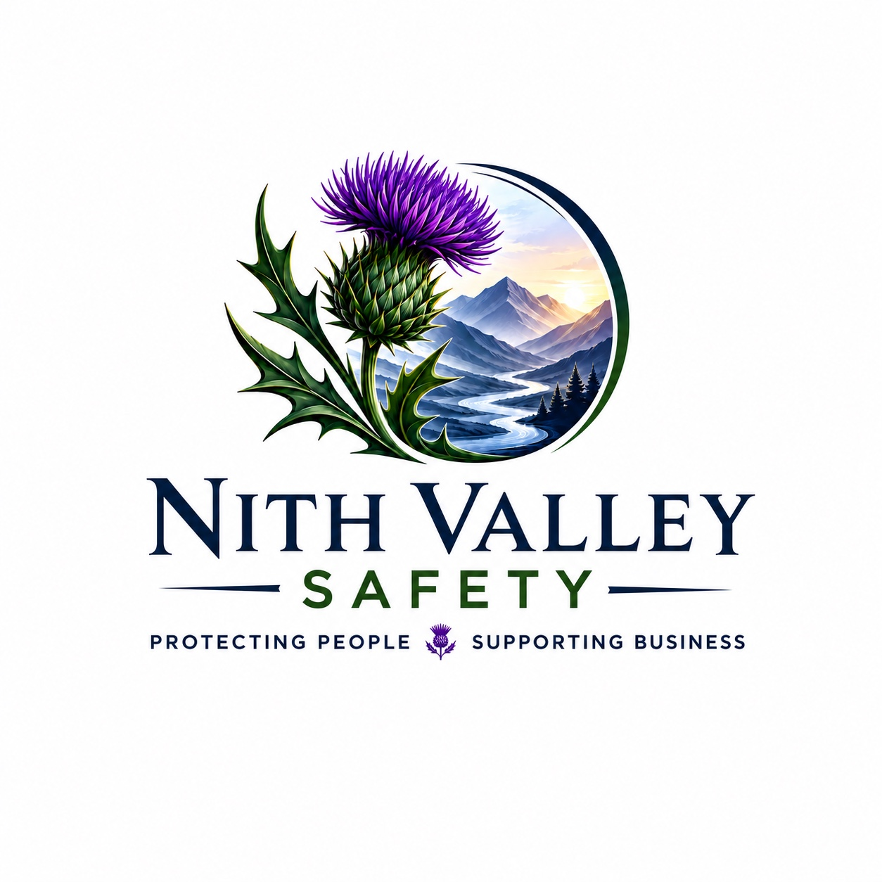
Effective health and safety documentation forms the foundation of a successful health and safety management system. Well-maintained records demonstrate legal compliance, support risk management, provide evidence of due diligence, and help organisations continually improve workplace safety.

Why Health and Safety Documentation is Important
- Demonstrates compliance with legal duties.
- Provides clear guidance for employees.
- Supports effective risk management.
- Creates consistency across the organisation.
- Provides evidence during inspections, audits and investigations.

Key Health and Safety Documents
- Health and Safety Policy.
- Risk Assessments.
- COSHH Assessments.
- Fire Risk Assessments.
- Safe Systems of Work (SSoW).
- Method Statements (RAMS).
- Training Records and Competency Certificates.
- Accident and Incident Records.
- Inspection and Audit Reports.
- Emergency Plans and Evacuation Procedures.

Document Control
- Ensure documents are current and approved.
- Review documents regularly.
- Withdraw obsolete versions.
- Store records securely and make them accessible to relevant employees.

Responsibilities
- Employers should develop, maintain and review documentation.
- Managers should implement documented procedures.
- Employees should follow documented arrangements and report inaccuracies.

Best Practice
- Use clear and simple language.
- Keep documentation up to date.
- Communicate changes to employees.
- Retain records in accordance with legal and business requirements.

Benefits
- Improved legal compliance.
- Better communication and accountability.
- Reduced workplace risk.
- Enhanced business continuity.
- Continual improvement of health and safety performance.

Conclusion
Accurate and well-managed health and safety documentation helps organisations protect people, demonstrate compliance and support continual improvement. Maintaining clear, up-to-date records is an essential part of creating a safe and well-managed workplace.

